CURRICULUM VITAE
MD. ATIKUL ISLAM
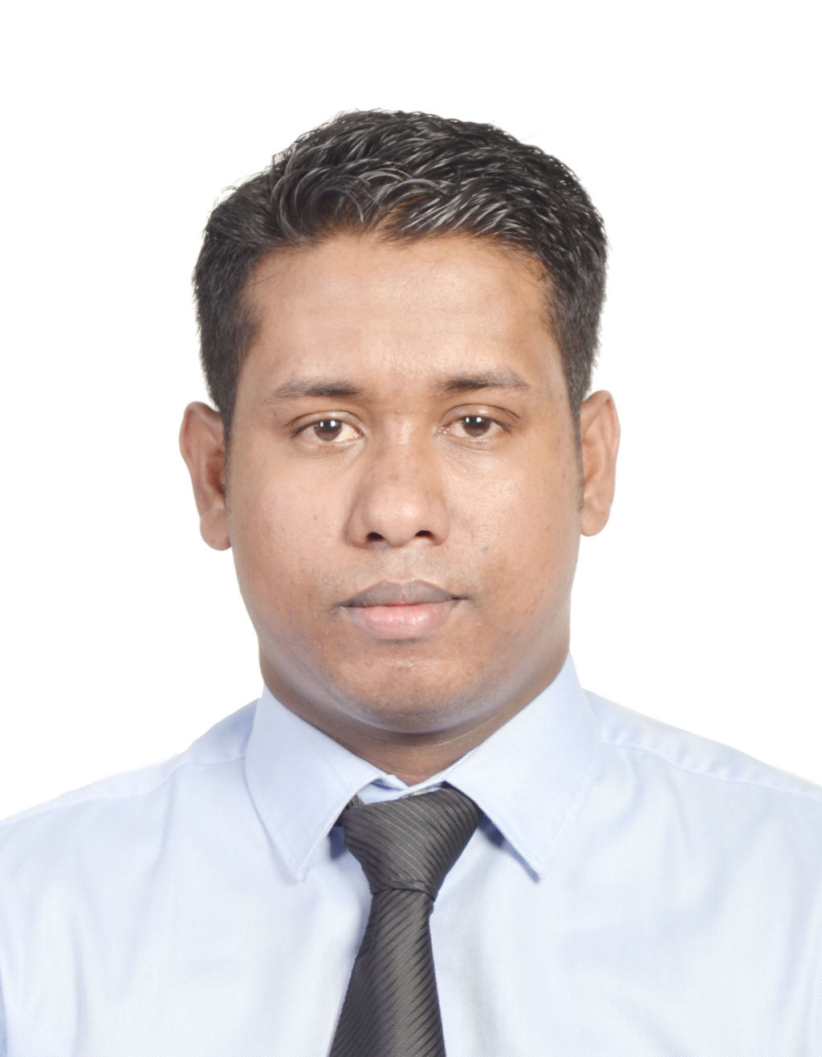
Address for Correspondence:

Flat No: 24-6-B, 24th Floor, B Block
Menara City One Condominium,
Jalan Munshi Abdullah,
50100 Kuala Lumpur,
Malaysia.
Cell: +601121200588
E-mail: atikuldesk@gmail.com

Career Objective:

Enhance professional experiences, in the field of IT, Telecommunication and Power Sector, especially in the fields of monitoring and evaluation, research and organizational development. Personal objectives are to prove my skills and demonstrate my devotion to the job.

Educational Background:

LINCOLN UNIVERSITY COLLEGE, MALAYSIA. Sep. 2014- Apr 2016
Master of Science in Electrical and Electronics Engineering
Emphasis in Electrical Power Systems

- Electrical power supply generation and distribution including renewable.
- Transport and industrial equipment manufacturers employing electrical drives.
- Industrial measurement and monitoring systems.
- Microelectronic applications.
- Study on Mechanical and Electrical Design of Overhead Transmission line.

WORLD UNIVERSITY OF BANGLADESH Mar 2009 - Apr 2013
Bachelor of Science in Electrical and Electronic Engineering
Emphasis in Electrical Power Systems

- Integrate conceptual understanding of mathematics.
- Numerical analysis, statistics, and computer and information sciences with advanced specialist bodies of knowledge within the electrical and electronic engineering discipline.
- Apply professional ethics and accountabilities in their engineering practice.
- Critically evaluate both sources and validity of information and use established processes for information management.
- Adapt theoretical knowledge applicable to the discipline and propose creative, innovative and sustainable engineering practices.
- A study on improvement of voltage profile of a power system using facts device (STATCOM).

Work Experience:

1. DNS Engineering & Communications Ltd. as a System Engineer since July 01, 2013 to January 31 2014
House # 12 & 14, Road # 02, Banani, Dhaka - 1213.
Web: www.dnse.com.bd
Responsibilities:
1. Dealings with operator and vendors.
2. Installation & Commissioning of Micro-Wave Equipments.
3. Optimization and Site Survey (OSS) for GP Project.

Technical skills:

Operating System : Windows 2000, XP, Vista, Windows 7, 8,Android.
Language : HTML, CSS3
Using Tools : Matlab, Photoshop, illustrator, Dreamweaver.
Application Program : MS-Office 2010, 5Spice, Electro droid, Adobe Creative Suite CS5, AutoCAD 2010.

Others skills:

- Ability to work in a competitive and challenging work environment.
- Capable of working under pressure.
- Ability to work independently or in a group.
- Always ready with new and innovative ideas.
- Diligent and motivated toward goal.
- Dedicated to professionalism.
- Creativity.

Area of Interest:

I would like to work in such an area where, I can prove my skills and abilities through challenges in growth-oriented company.
- Manufacturing
- Automobile
- Electrical power plant
- Electrical Maintenance
- Telecommunication
- Information Technology

Trainings:

- “German Language” Goethe Institute Dhaka (150 hrs)
- "Graphics Design” from Bhuiyan Computers of kalabagan branch
- “Matlab and Electric AutoCad” from online resources.

Languages:

- A good command in Bengali and English both oral and written.
- German language level A1
- Good Hindi and Urdu oral communicate.

Personal Information:

Father’s Name : Md. Shahidul Islam
Mother’s Name : Jahanara Begum
Permanent Address : 17/D, Housing State,
Goalchamot, Faridpur 7804.
Date of birth : 28 September 1989.
Place of birth : Faridpur, Bangladesh
Marital Status : Unmarried
Nationality : Bangladeshi
Sex : Male
Height & Weight : 5'-7.5" & 75kg
Blood Group : B+ (ev)

References:
Md. Ashraful Islam  Microwave Engineer  NPD/TSD  Huawei Technologies (Bangladesh)  RM Center (2nd Floor), 101 Gulshan avenue  Gulshan, Dhaka-1212, Bangladesh.  Cell: +8801745733489 | Datuk Prof. IR. Ismail Hassan  Professor and Head of the Department  Electrical & Electronic Engineering  Lincoln University College  Kuala Lumpur Malaysia.  Email : ismail@lincoln.edu.my  Cell : +60126075132

Declaration:

I am the undersigned by declare that I will be responsible for any information provided here.

Date: MD Atikul Islam

